Lab No-**02**

Name of the lab: **Linux Command**

Name: **Shuvo Biswas** ID: **IT-16014**

***Objective:***

Linux is a Unix free operating system for computer devices. Linux is an special type operating system which makes the hardware work together with the software.In our computer ,we run linux operating system by using many useful command. This commands are writing in the shell command line which is also called a terminal emulator. By getting this command instructions ,linux works our computer.There are many commands we use. These are given below:

***Our first linux commands***

1. *ls*
2. *pwd*
3. *cd*

***The basic commands***

*(4)df*

*(5)mkdir*

*(6)rm*

*(7) whoami*

*(8) hostname*

*(9) ls –a*

*(10)cd ..*

*(11)cd .. ..*

*(12)rmdir*

*(13)rm –r*

*(14)gedit*

**Varies types of Linux command and their proper use are given below:**

**1.ls:** Ls stands of shorts of list. ls lists the files in the current working folder.

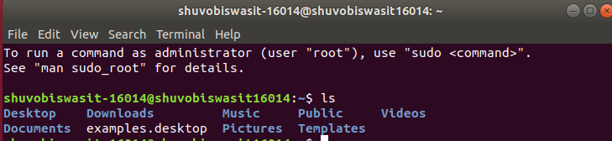

**2.whoami:** This command prints the username associated with the current effective user ID.

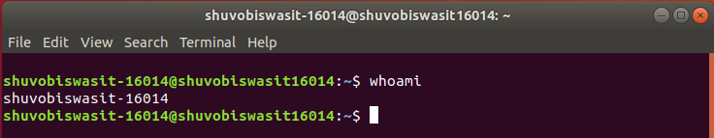

**3.hostname:** The hostname command shows or sets the system hostname.

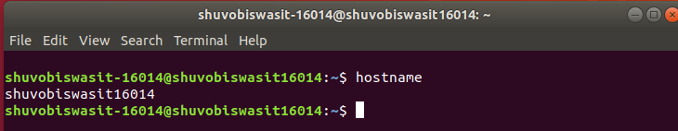

**4.pwd:** hort for **print working directory**, **pwd** is a Linux, Unix, and FTP command to print the directory you're currently working in when at the command line.

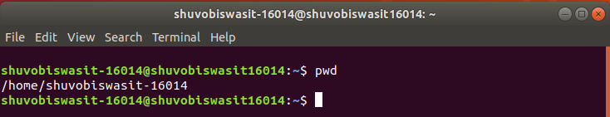

**5.ls –a:** list all files including hidden file starting with

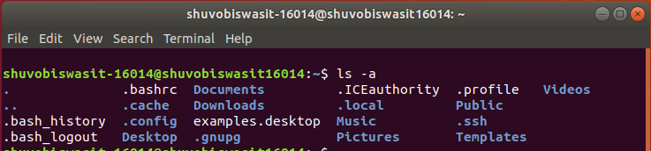

**6.cd:** The cd command, which stands for "change directory", changes the shell’s current working directory .

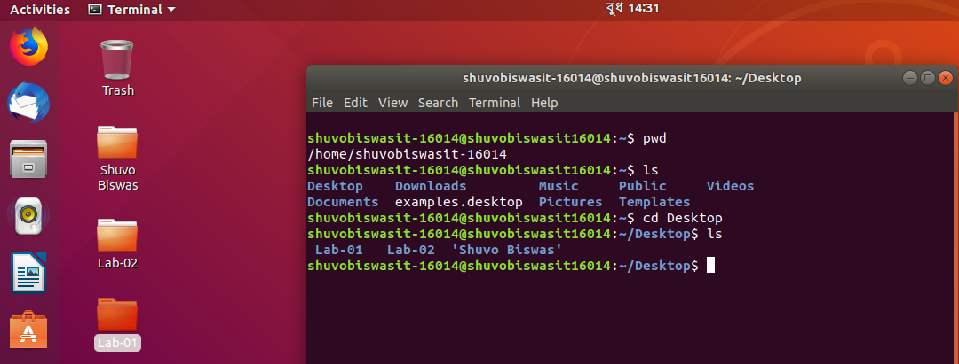

**7.mkdir:** The mkdir command creates new directories in your file system.

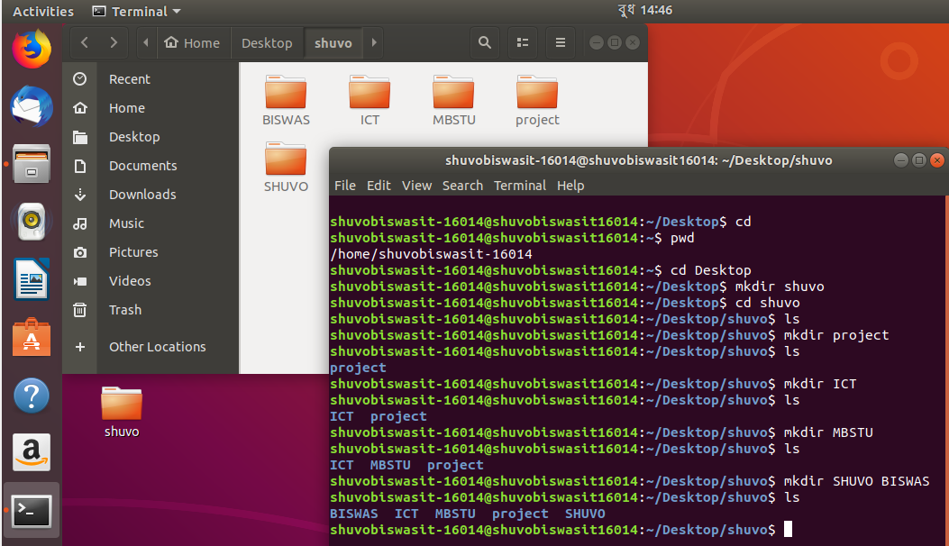

**8.cd .. :**Move one directories up.

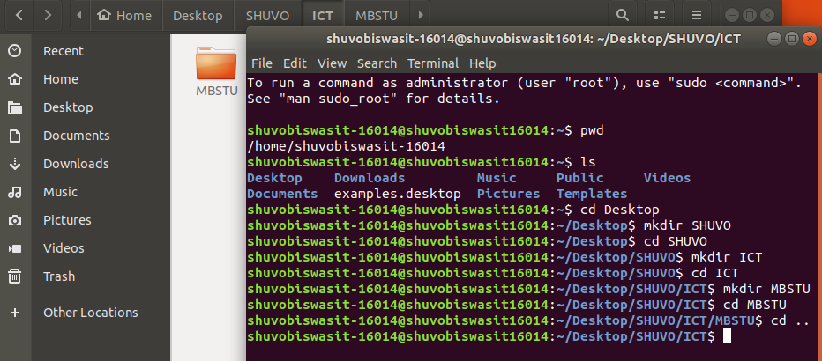

**9:cd .. .. :** Move two directories up.

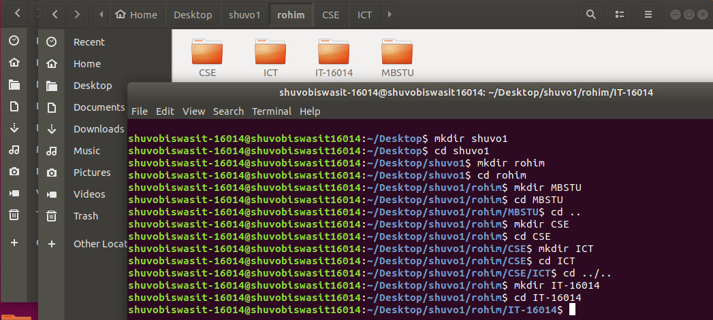

**10.rmdir:** remove a directory from the desktop.

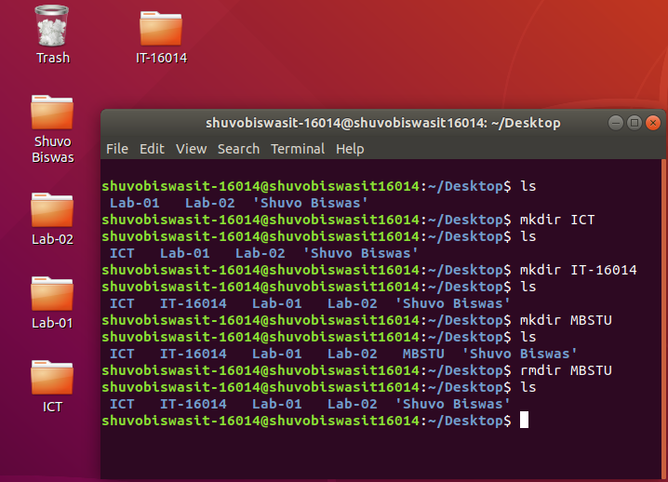

**11.rm –r**: remove directory with its content from the desktop.

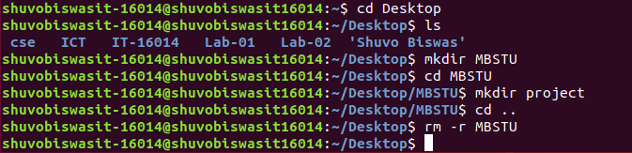

**12.gedit:** Working with text editors: Then we write many important information $ gedit ---> its an editor

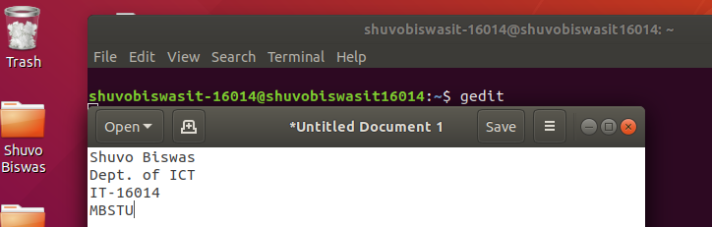

**13.df:** view filesystem disk space usage

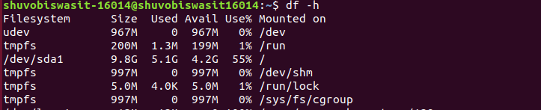

***Discussion:***

If we want to use linux operating system ,we must know the basic linux command.

By using this linux command we can solve any complex problem in our linux operating system.

These linux command are very simple and flexible. I learn many important rules and hoe write command into terminal by using this lab.